Data Technician Week 5
Workbook
Azure Data Fundamentals

Name:
Course Date:
Table of contents
Day 1: Task 1 3
Day 1: Task 2 4
Day 1: Task 3 5
Day 2: Task 1 6
Day 3: Task 1 10
Day 3: Task 2 11
Day 3: Task 3 12
Day 4: Task 1 13
Day 4: Task 2 14
1. Scenario Background 14
2. Data Laws and Regulations 14
3. Azure Service Recommendations 14
4. Data Types and Data Modelling 14
5. Data Storage Formats and Structures in Azure 15
6. Additional Considerations 15
Submission Guidelines: 15
Course Notes 18
Additional Information 19

Day 1: Task 1

Please research and complete the below questions relating to key concepts of cloud.

Be prepared to discuss the below in the group following this task.

What can cloud computing do for us in the real-world? | Cloud computing enables us to have access to on demand customised IT recourses over the cloud/internet in exchange for money.  Eg.; If we want to play a videogame that requires higher graphics and we don’t have its hardware requirements, we can rent a cloud infrastructure and run the game.
How can it benefit a business? | Business gather data and requires dynamic resource management to meet and adjust to its IT requirements. It allows them to lower costs, scale operations and allow remote work.
What’s the alternative to cloud computing? | Alternative to cloud computing is running and storing in-house servers which are able to get access to even without the need for internet connectivity.
What cloud providers can we use, what are their features and functions? | Features AWS Azure GCP  Serverless Computing AWS Lambda Azure Functions Google Cloud Functions  Docker Management ECS Container Service Container Engine  Managing Data AWS Redshift SQL Wearhouse Big Query

Day 1: Task 2

Please research the below cloud offerings, explain what they are and examples of use cases.

Cloud Offerings | Explain what it is | When / how might you use this service in the real-world?
IaaS (Infrastructure as a service) | PaaS is a cloud computing service that provides a ready-made platform for developers to build, test, and deploy applications without managing servers, storage, or networking. | It allows businesses to rent IT infrastructure instead of purchasing and managing physical hardware, offering high flexibility and scalability to reduce capital expenditure.
PaaS (Platform as a service) | PaaS is a cloud computing model where software applications are delivered over the internet and accessed through a web browser, without needing installation on local devices. The provider manages everything, including infrastructure, updates, and security. | PaaS is ideal for software development teams who want to focus only on coding and application development.
SaaS (Software as a service) | SaaS is a cloud computing model where software applications are delivered over the internet and accessed through a web browser, without needing installation on local devices. The provider manages everything, including infrastructure, updates, and security. | It is appropriate for businesses and individuals who simply want to use software without managing technical setup. For example, companies use Microsoft 365.

Day 1: Task 3

Please research the below terms and explain what they are, when they would be appropriate and a real-world example of where it could be implemented (i.e. what type of organisation).

Public Cloud | A public cloud is a cloud computing model where services such as servers, storage and applications are provided by a third party. For example: AWS, Microsoft Azure, Google Cloud Platform. They would be appropriate if an organization such as a School would like to host their learning material over cloud so that all student can have access to it instead of buying and managing servers and hosting them study materials from the school itself which would increase the cost of operating and maintenance as well.
Private Cloud | A private cloud is a cloud computing model where an organisation hosts their services from their in-house servers. They would be appropriate if an organisation requiring high level of control, security and regulations such as banks, hospitals and government departments.
Hybrid Cloud | A hybrid cloud is a cloud computing model which combines both public cloud and private cloud. For example; A hospital may store patient records on a private cloud for security and legal compliance, while using Microsoft Azure (public cloud) to host their website or appointment booking system.
Community Cloud | A community cloud is a cloud infrastructure shared by several organisations that have similar requirements such as their security and compliance. For example branches of a school chain using community cloud for sharing their data.

Day 2: Task 1

Describe, with examples, the three major areas that the Computer Misuse Act deals with.

Area | Description | Example
Unauthorised Access to Computer Material | It is illegal to access a computer or data without having permission. | E.g., Accessing system files without authorisation/permission.
Unauthorised Access with Intent to Commit Further Offences | Accessing a system without authorisation (which is an offence by itself) with intent to commit another offence(s). | E.g., Hacking into a system to steal information such as credit card details.
Unauthorised Modification of Computer Material | It is illegal to alter, damage, or delete files without prior permission to do so. | E.g., Sending files containing malware deliberately or deleting files from a company system.

The computer misuse act 1990 is an act where an individual can be criminalised because of computer related offense. Describe three extra powers that the Police and Justice Act 2006 (Computer Misuse) has added.

Description
- It is illegal to create, supply, or obtain hacking tools for committing computer misuse offences. E.g., Selling a software to bypass windows activation.

- Increased maximum sentence to 10 year in prison for serious crimes.

- Made Denial-of-Service (DoS) attack illegal.

Look at the below website to answer the questions:
https://www.gov.uk/personal-data-my-employer-can-keep-about-me

Write down three items of data which a company can store about an employee.
- Name

- Address

- Date of birth

Give three more examples of data that an employer can only store if they first get the employee’s permission.
- Religion

- Trade union membership
- Biometrics

Conduct further research to answer the below questions.

Question | Answer
Provide one example of: Copyright infringement | Installing and activating a Windows copy through unofficial activation tools.
Provide one example of: Plagiarism | Copying someone else’s text and presenting it as your own.
What are two consequences of copyright infringement and software piracy? | Loss of reputation and legal fines.
Give three possible consequences for individuals when using pirated software | Lack of support & security updates, risk of viruses and legal action.

Listed below are some laws which we have covered today:

1. Computer Misuse Act 1990
2. Police and Justice Act 2006 (Computer Misuse)
3. Copyright, Designs and Patents Act 1988
4. Copyright (Computer Programs) Regulations 1992
5. The Health and Safety (Display Screen Equipment) Regulations 1992
6. Data Protection Act 2018
7. Consumer Rights Act 2015
- Insert a number in the first column of each row to match each of the statements with one of the above Acts.

- One of statements is incorrect and not illegal. For this statement, write ‘Not illegal’.

Act number | Clause
4 | With some exceptions, it is illegal to use unlicensed software
7 | Any product, digital or otherwise, must be fit for the purpose it is supplied for
1 | Unauthorised modification of computer material is illegal
Not illegal | It is illegal to create or use a hacking tool for penetration testing
6 | Personal data may only be used for specified, explicit purposes
5 | Employers must provide their computer users with adequate health and safety training for any workstation they work at
2 | It is illegal to distribute hacking tools for criminal purposes
3 | It is illegal to distribute an illicit recording
6 | Personal data may not be kept longer than necessary
1 | Gaining unauthorised access to a computer system is illegal
5 | Employers must ensure that employees take regular and adequate breaks from looking at their screens
2 | It is illegal to prevent or hinder access (e.g. by a denial-of-service attack) to any program or data held in any computer
6 | Personal data must be accurate and where necessary kept up to date

Day 3: Task 1

Please complete the below lab (1) ‘Explore relational data in Azure’ and paste evidence of the completed lab in the box provided.

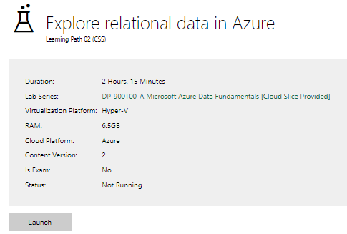

Completed lab | 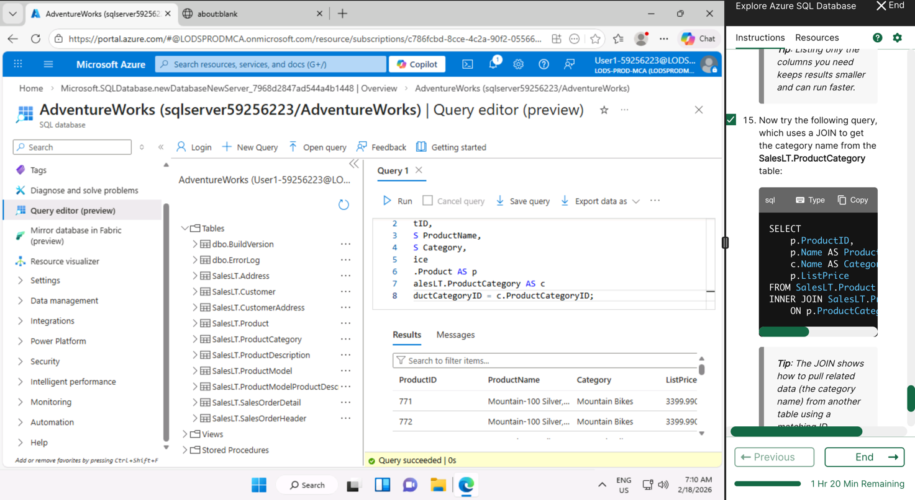

Day 3: Task 2

Please complete the below lab (2) ‘Explore non-relational data in Azure’ and paste evidence of the completed lab in the box provided.

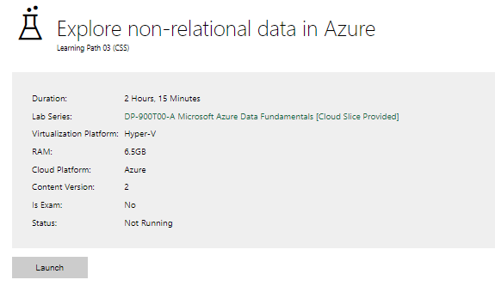

Completed lab | 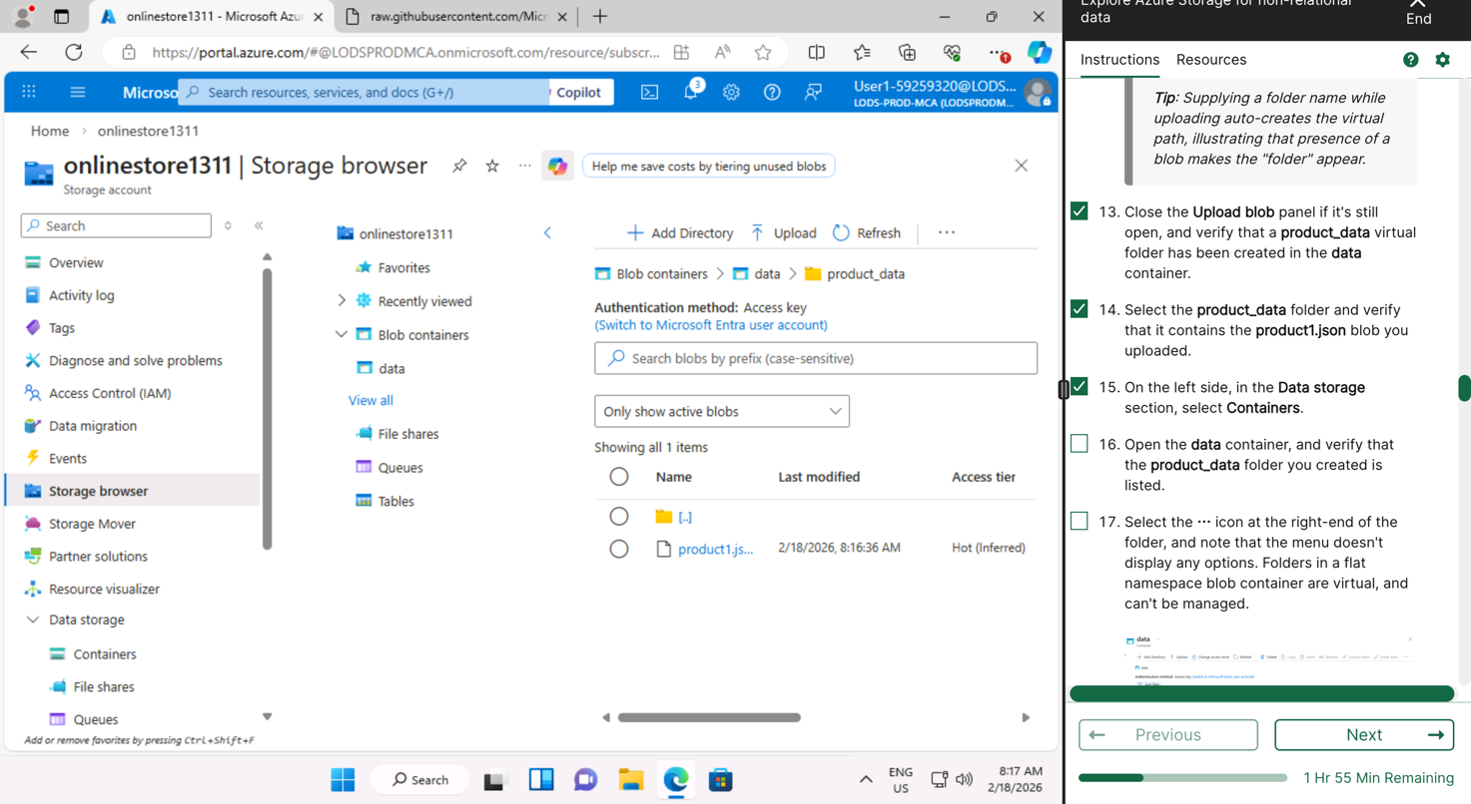  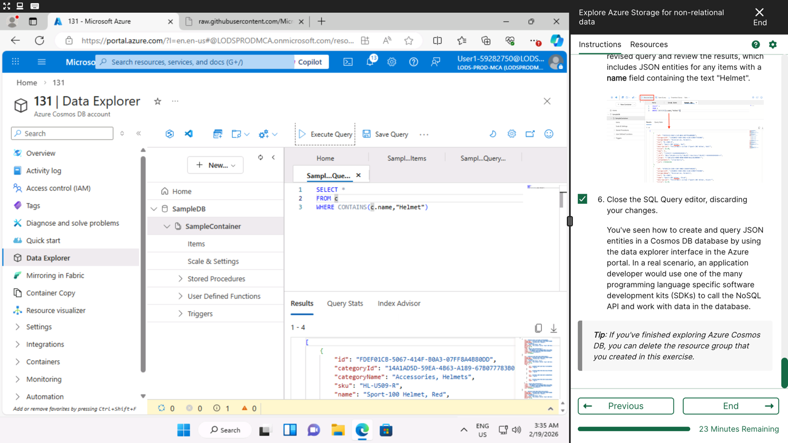

Day 3: Task 3

Please complete the below lab (3) ‘Explore data analytics in Azure’ and paste evidence of the completed lab in the box provided.

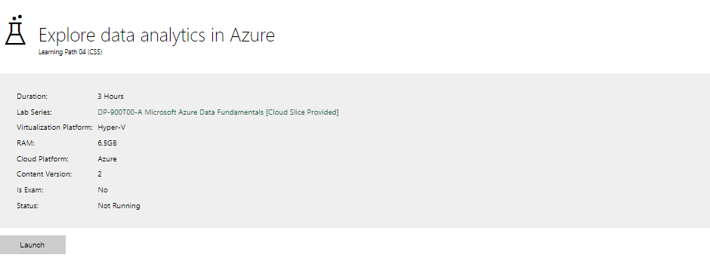

Completed lab | 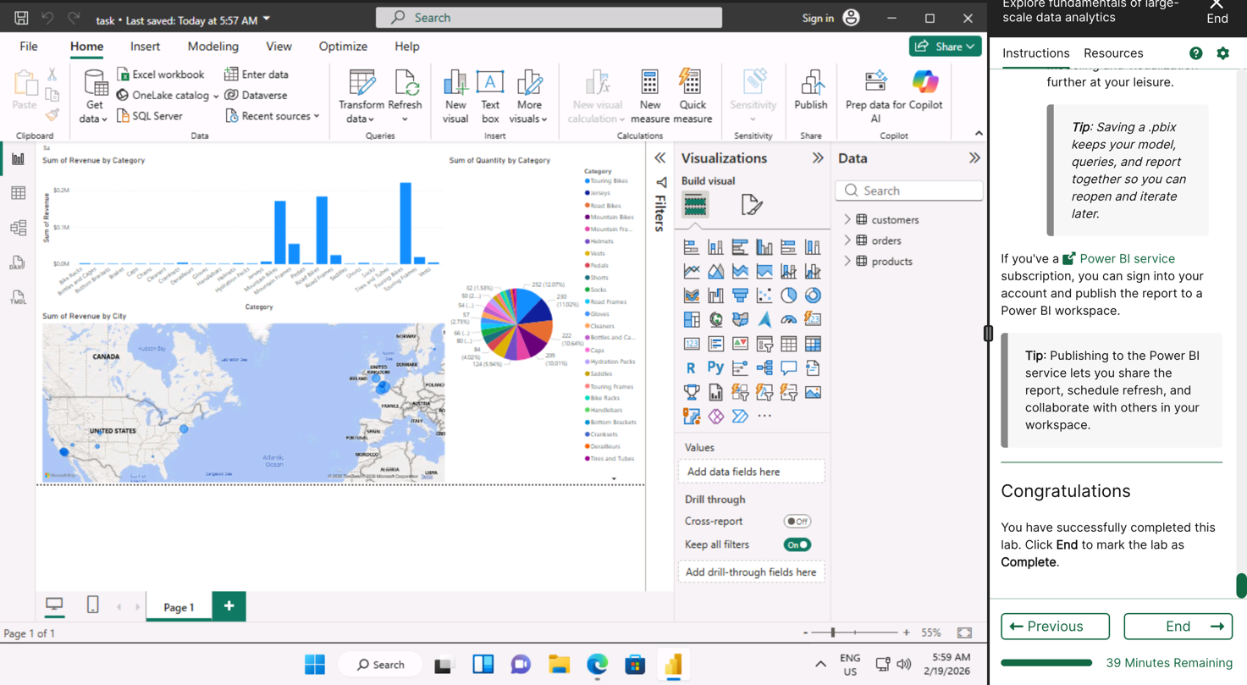

Day 4: Task 1

In your teams, complete the Azure DP-900 practice exam and paste your result below – this is open book and please research and discuss your answers as a team.

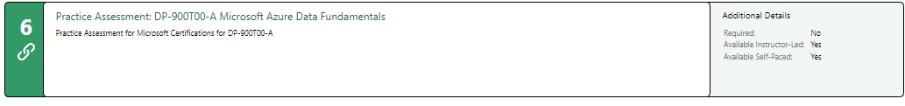
Result | 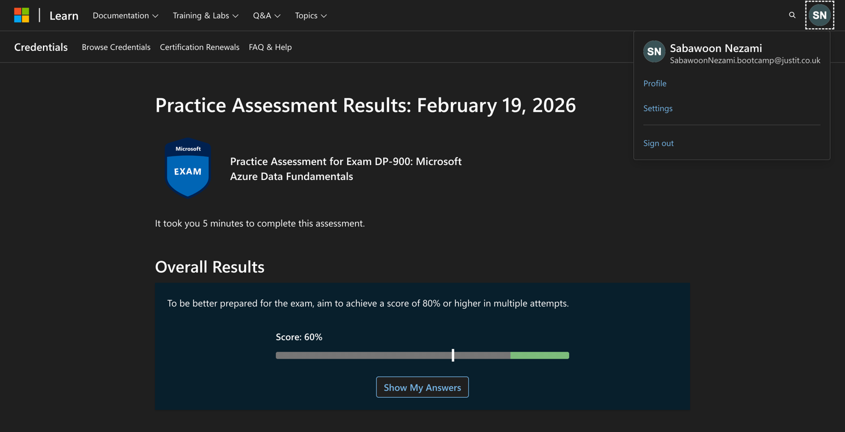

Day 4: Task 2

1. Scenario Background
"Paws & Whiskers" is a growing pet shop that aims to improve its business by analysing sales, customer information, and inventory data. Currently, the data is collected manually or stored in spreadsheets. Management is interested in transitioning to Microsoft Azure to streamline data storage, analysis, and reporting, enabling them to make data-driven decisions.

2. Data Laws and Regulations
Identify and explain the data laws and regulations relevant to handling customer data within the proposal. Ensure you cover the following points:
- GDPR Compliance: Highlight the importance of adhering to the General Data Protection Regulation (GDPR), particularly as it relates to storing and processing customer information.
- Data Protection Act (DPA) 2018: Outline how the DPA 2018 may affect the way "Paws & Whiskers" collects and stores data, ensuring compliance with UK laws on data privacy.
- Other Industry Standards: Research any additional data protection standards or regulations that may apply to pet shop data, particularly if they involve sensitive or payment information.

3. Azure Service Recommendations
Recommend Microsoft Azure services that would suit the company’s data analysis needs and explain why these services are suitable. Your recommendations should include:
- Data Storage: Identify suitable storage options, such as Azure Blob Storage or Azure SQL Database, and discuss the benefits of each for storing large datasets, including inventory, sales transactions, and customer details.
- Data Analysis Tools: Recommend tools such as Azure Machine Learning for customer behaviour analysis or Azure Synapse Analytics for analysing sales trends.
- Data Integration and Automation: Explain how services like Azure Data Factory could automate data collection and integration processes, improving efficiency.

4. Data Types and Data Modelling
Define the types of data "Paws & Whiskers" will need to work with and describe your approach to data modelling:
- Data Categories: Identify key data types, such as customer demographics, transaction history, pet inventory, and product categories.
- Data Modelling Approach: Outline how you would structure this data using a relational model or a data warehouse approach, considering factors like tables, entities, relationships, and primary keys.

5. Data Storage Formats and Structures in Azure
Discuss how you would store data within Azure and the formats you would recommend:
- Data Formats: Specify recommended formats (e.g., CSV for raw data imports, JSON for structured data, Parquet for analytics) and explain why these formats are suitable for specific data types.
- Data Security and Encryption: Include recommendations for securing data using Azure’s built-in encryption features and access controls to ensure compliance with data privacy regulations.

6. Additional Considerations
Provide any other considerations that might enhance data handling and efficiency in Azure, such as:
- Backup and Disaster Recovery: Outline a backup plan using Azure Backup or Azure Site Recovery to safeguard against data loss.
- Data Visualisation: Discuss potential use of Power BI within Azure for creating dashboards that provide management with real-time insights into sales and customer trends.
- Future Scalability: Comment on how Azure services can scale as the business grows, accommodating larger datasets and more complex analyses.

Submission Guidelines:
- Structure: Ensure your report is well-organised, with sections for each task (e.g., Data Laws, Azure Services, Data Types, etc.).
- Formatting: Include headings, bullet points where appropriate, and any visuals or diagrams that support your explanations.
- References: Cite any resources or regulations referenced in the report.
- Length: Aim for 1500-2000 words.

Data Laws and Regulations
- GDPR Compliance: Only necessary data should be collected accurately and stored safely. Failure to comply can result in fines up to £17.5 million or 4% of annual turnover.
- Data Protection Act (DPA) 2018: This means they should be transparent and post their privacy notice and in case of breach they’ll have to report it to ICO within 72 hours.
- Other Industry Standards: If the pet shop processes card payments, it must comply with PCI DSS (Payment Card Industry Data Security Standard)

      - Azure Service Recommendations

- Data Storage: 1. Azure Blob Storage: Its suitable to store unstructured data like receipts, is scalable, cost efficient and suitable for long term archival.
Data Analysis Tools: Azure Machine Learning could be used for customer purchase behaviour prediction and forecasting demands.
- Data Integration and Automation: Azure Data Factory could automate data collection and integration processes, improving efficiency by reducing manual work and minimising human error.

      - Data Types and Data Modelling

Paws & Whiskers will need to work with data types, such as customer demographics, transaction history, inventory, and product categories.
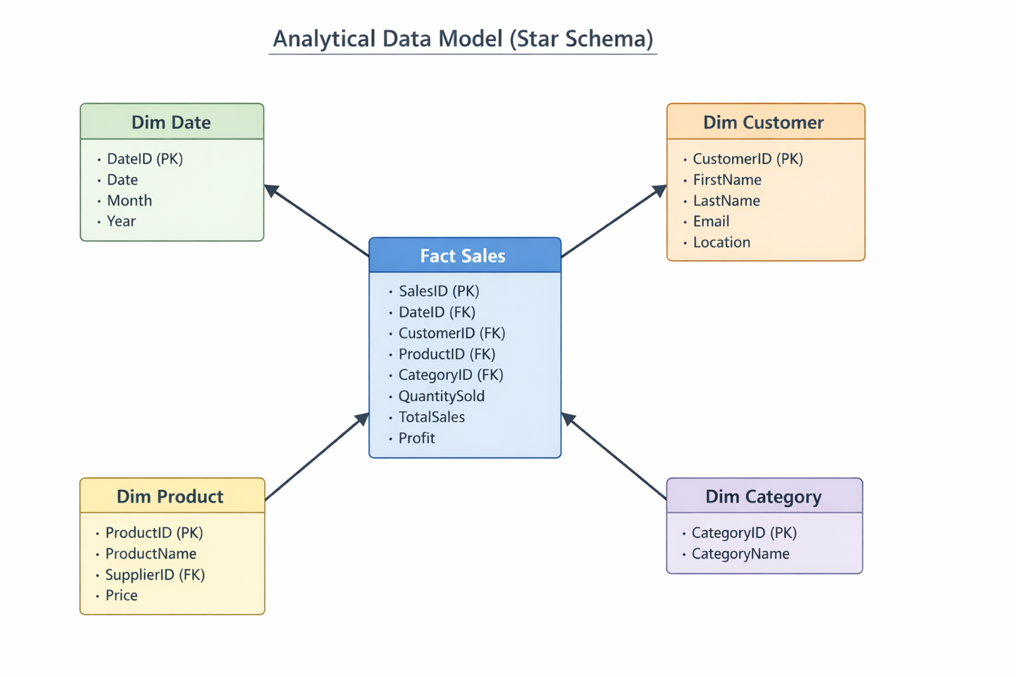
This structure enables efficient aggregation and reporting, allowing management to analyse trends such as total sales by month, revenue by product category, or customer purchasing behaviour over time.

Data Storage Formats and Structures in Azure
- I would recommend CSV for raw data imports because it’s simple and compatible with many systems, JSON for structured data because its lightweight and easy to integrate with web systems and Parquet for analytics.
- Data Security and Encryption: It is highly recommended to secure data using Azure’s built-in encryption features and access controls to ensure compliance with data privacy regulations.

- Additional Considerations

To improve reliability and efficiency, Paws & Whiskers should use Azure tools for backup, security, and reporting. Azure Backup and geo-redundant storage can protect the business from losing data if there is a system failure or human error. Power BI can be connected to Azure databases to create simple dashboards that show daily sales, stock levels, and customer trends, helping management make better decisions. Azure is also scalable, which means as the business grows and has more customers or products, the system can easily handle more data without needing to replace the whole setup.

- References

- General Data Protection Regulation (GDPR)
- Data Protection Act 2018 UK
- Information Commissioner's Office (ICO)
- PCI DSS Standards Council

Course Notes

It is recommended to take notes from the course, use the space below to do so, or use the revision guide shared with the class:

Additional Information

We have included a range of additional links to further resources and information that you may find useful, these can be found within your revision guide.

END OF WORKBOOK

Please check through your work thoroughly before submitting and update the table of contents if required.

Please send your completed work booklet to your trainer.

